**IFT 166 Introduction to Internet Networking**

**Lab 9: Workbook**

**(Numbering Systems, IP Addressing and Classful Subnetting)**

**Lab 9: Instructions**

1. You cannot use the Internet to complete the workbook…….I’m watching you ☺ somehow
2. You must complete the workbook on your own. You can ask for help of other students, but this is not a team task.
3. Only use a calculator when prompted.

**Lab Sections**

* Part A: Decimal to Binary conversion
* Part B: Binary to Decimal conversion
* Part C: Decimal to Hexadecimal conversion
* Part D: Hexadecimal to Binary conversion
* Part E: Hexadecimal to Decimal conversion
* Part F: Numbering system revision questions
* Part G: Windows calculator and numbering systems
* Part H: Address Class Identification
* Part I: Network & Host Identification
* Part J: Network Addresses
* Part K: Host Addresses
* Part L: Default Subnet Masks
* Part M: ANDing Process

**Please read this page before you attempt parts a-f (inclusive)**

**Numbering Systems**

Any system of naming/representing numbers or a set of numerals for representing numbers

**Decimal system (base 10)**

* Decimal counting system we use every day.
* Uses 10 digits 0,1,2,3,4,5,6,7,8,9
* Computers only display numbers in decimal, they actually do all their work in binary

**Binary system (base 2)**

* Based on only two numbers 0 and 1.

**Hexadecimal (base 16)**

* Use 16 unique digits (0,1,2,3,4,5,6,7,8,9,A,B,C,D,E, F)
* Used on NIC cards and IPv6 addressing.
* Each hex value represents 4 bits.

Byte range from 00000000-11111111 with decimal range from 0-255 or hex values 0-ff

* To avoid confusion while using different numeral systems, the base of each individual number may be specified by writing it as a subscript of the number.
* For example the decimal number 512 may be written as 51210
* The hexadecimal number 512 may be written as 51216 or with a 0x prefix

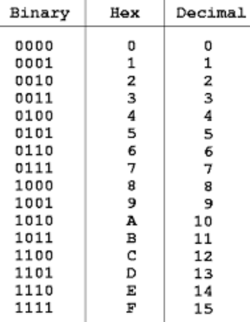

**Part A: Decimal to Binary Conversion**

(Use all 8 bits to represent each answer)

Calculator is not permitted in this section.

|  |
| --- |
| 128 64 32 16 8 4 2 1 = 255 |
| 1 1 1 0 1 1 1 0 238 |
| 0 0 1 0 0 0 1 0 34 |
| 123 |
| 50 |
| 255 |
| 200 |
| 10 |
| 138 |
| 1 |
| 13 |
| 250 |
| 107 |

**Part B: Binary to Decimal Conversion**

Calculator is not permitted in this section.

|  |
| --- |
| 128 64 32 16 8 4 2 1 = Ans |
| 1 0 0 1 0 0 1 0 146 |
| 0 1 1 1 0 1 1 1 119 |
| 1 1 1 1 1 1 1 1 |
| 1 1 0 0 0 1 0 1 |
| 1 1 1 1 0 1 1 0 |
| 0 0 0 1 0 0 1 1 |
| 1 1 1 0 0 0 0 0 0 1 |
| 00011011 |
| 10101010 |
| 01101111 |
| 11111000 |
| 00100000 |
| 01010101 |

**Part C: Decimal to Hexadecimal Conversion**

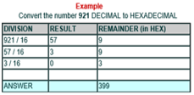Calculator is not permitted in this section.

**Procedure**

1. Divide the decimal number by 16.
2. Write down the remainder (in hexadecimal).
3. Divide the result again by 16.
4. Repeat step 2 and 3 until result is 0.
5. The hex value is the digit sequence of the remainders from the last to first.

**(Answer the following)**

|  |  |
| --- | --- |
| **Decimal** | **Hexadecimal** |
| 53 |  |
| 273 |  |
| 105 |  |
| 158 |  |
| 171 |  |
| 85 |  |
| 496 |  |
| 112 |  |
| 897 |  |
| 5, 292 |  |

**Part D: Hexadecimal to Binary Conversion**

Calculator is not permitted in this section.

Convert a hexadecimal number to binary by simply translating each hexadecimal digit into its 4-bit binary equivalent.

For example, the hexadecimal number 0x9E3 translates into 1001 1110 0011, as the binary values of 9, E and 3 are 1001, 1110 and 0011.

**Answer the following**

|  |  |
| --- | --- |
| **Hexadecimal** | **Binary** |
| 0x68 |  |
| 0xF2 |  |
| 0X19 |  |
| 0X123 |  |
| 0X2BB |  |

**Part E: Hexadecimal to Decimal Conversion**

Calculator is not permitted in this section.

Converting hexadecimal to decimal can be performed in the conventional mathematical way, by showing each digit place as an increasing power of 16

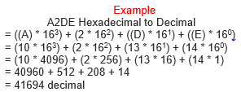



**Answer the following**

|  |  |
| --- | --- |
| **Hexadecimal** | **Decimal** |
| 0x35 |  |
| 0x1AA |  |
| 0x12 |  |
| 0x4B |  |
| 0x89 |  |

**Part F: Numbering system revision questions**

Calculator is not permitted in this section.

|  |  |  |
| --- | --- | --- |
| **Decimal** | **Hexadecimal** | **Binary** |
|  | A9 |  |
|  | FF |  |
|  | BAD1 |  |
|  | 38C |  |
|  | 142 |  |
| 23 |  |  |
| 255 |  |  |
| 115 |  |  |
| 67 |  |  |
| 19 |  |  |
|  |  | 10101010 |
|  |  | 1111 |
|  |  | 10111101 |
|  |  | 111 |
|  |  | 11110000 |

**Part G: Windows Calculator & Numbering Systems**

Calculator is permitted in this section.

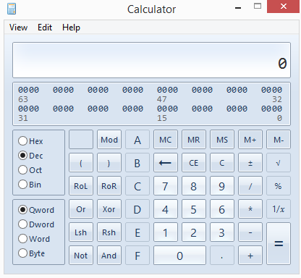

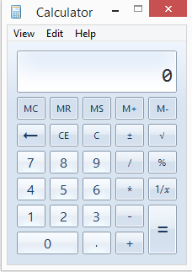

**Objectives**

* Switch between Windows Calculator modes.
* Use Windows Calculator to convert between decimal, binary, and hexadecimal.
* Use Windows Calculator to determine the number of hosts in a network with powers of 2.

**Step 1: Access Windows Calculator and determine mode of operation**

1. Open the calculator on Windows 8 or Windows 10(whatever method you want)..screens may vary.
2. Once the Calculator application opens, select the **View** menu option.
3. Which mode is currently active?

_________________________________

1. Select the Standard mode. This is a basic mode for simple calculations. How many mathematical functions are available in this mode?

__________________________________________________

1. From the View menu option, select the Scientific Calculator mode.
2. How many mathematical functions are available in this mode? __________________________

**Step 2: Convert between number systems**

1. Access **Programmer** mode. Notice the number system modes available—Hex (Hexadecimal), Dec (Decimal), Oct (Octal), and Bin (Binary).
2. Which number system is currently active?

________________________________________

1. Which numbers on the number pad are active in Decimal mode?

_______________________

1. Click on the **Bin** (Binary) mode radio button. Which numbers on the number pad are now active?

___________________________________

1. Why do you think the other numbers are grayed out?

___________________________________________________________________________

1. Click on the **Hex** (Hexadecimal) mode radio button.
2. Which characters on the number pad are now activated?

______________________________

1. Click on the **Dec** radio button. Using your mouse, click on the number **1** followed by the number **5** on the number pad. The decimal number 15 has now been entered. Click on the **Bin** radio button.
2. What happened to the number 15 listed in the textbox at the top of the window?

_____________

1. By selecting different modes, numbers are converted from one number system to another. Select **Dec** mode again. The number in the window converts back to decimal. Select the **Hex** mode.
2. Which hexadecimal character (0 through 9 or A through F) represents decimal 15?

___________

1. Clear the hexadecimal value representing 15 in the window. Select **Dec** mode again. Not only can Clear the hexadecimal value representing 15 in the window. Select **Dec** mode again. Not only can the mouse be used to enter numbers, but the numerical keypad on the keyboard as well as numbers on the keyboard can also be used. Using the numerical keypad to the right of the ENTER key, type the number **22**. Note that if the number does not enter into the calculator, press the **Num Lock** key to enable the numeric keypad. While the number 22 is showing in the calculator, use the number keys across the top of the keyboard to add a **0** to the number 22 (220 should now be on the calculator). Select the **Bin** radio button.
2. What is the binary equivalent of 220?

_______________________________________________

1. Clear the binary value representing 220 in the window. From Binary mode, type in the following binary number: **11001100**. Select the **Dec** radio button.
2. What is the decimal equivalent to the binary number of 11001100?

________________________

**Step 3: Convert host IP addresses**

1. Computer hosts usually have two addresses, an Internet Protocol (IP) address and an Ethernet Media Access Control (MAC) address. For the benefit of humans, the IP address is normally represented as a dotted decimal notation, such as 135.15.227.68. Each of the decimal octets in the address or a mask can be converted to 8 binary bits. Remember that the computer only understands binary bits. If all 4 octets were converted to binary, how many bits would there be?

_____________

1. IP addresses are normally shown with four decimal numbers ranging from 0 to 255 and separated by a period. Convert the 4 parts of the IP address 192.168.10.2 to binary

|  |  |
| --- | --- |
| **Decimal** | **Binary** |
| 192 |  |
| 168 |  |
| 10 |  |
| 2 |  |

1. Notice in the previous problem how the 10 converted to only four digits and the number 2 converted to only two digits. When IP addresses can have any number from 0 to 255 in each position, eight digits are normally used to represent each number. In the previous example, eight digits were needed to convert 192 and 168 to binary, but 10 and 2 did not need as many digits. Normally 0s are added to the left of the digits to have eight digits in binary for each IP address number. The number 10 would be shown as 00001010. Four extra zeros are added to the front of the other four binary digits.
2. On the calculator in Binary mode, enter the digits **00001010** and select the **Dec** radio button.
3. Which decimal number is equivalent to 00001010?

___________

1. Did adding “leading” zeros affect the number any?

____________

1. What would the number 2 (in the previous example) be if you were to make it eight digits?

**Step 4: Convert host IP subnet masks**

1. Subnet masks, such as 255.255.255.0, are also represented as dotted decimal. A subnet mask will always consist of four 8-bit octets, each one represented as a decimal number. With the exception of decimal 0 (all 8 binary zeros) and decimal 255 (all 8 binary ones), each octet will have some number of ones on the left and some number of zeros on the right. Convert the 8 possible decimal subnet octet values to binary.

|  |  |
| --- | --- |
| **Decimal** | **Binary** |
| 255 |  |
| 255 |  |
| 255 |  |
| 0 |  |

|  |  |
| --- | --- |
| **Decimal** | **Binary** |
| 0 |  |
| 128 |  |
| 192 |  |
| 224 |  |
| 240 |  |
| 248 |  |
| 252 |  |
| 254 |  |
| 255 |  |

1. Convert the four parts of the subnet mask 255.255.255.0 to binary (above to the right)

**Step 5: Convert IP and MAC addresses for a host**

1. Click the **Start** button, select **Run**, type **cmd**, and press **Enter**. From the command prompt, type **ipconfig /all**.
2. Make a note of the IP address and physical address (also known as a MAC address).

IP Address:

______________________________________________________

MAC Address:

_____________________________________________________

1. Using the calculator, convert the four numbers contained in the IP address to binary.

|  |  |
| --- | --- |
| **Decimal** | **Binary** |
|  |  |
|  |  |
|  |  |
|  |  |

1. The MAC or physical address is normally represented as 12 hexadecimal characters, grouped in pairs and separated by dashes (-). Physical addresses on a Windows-based computer are shown in a format of xx-xx-xx-xx-xx-xx, where each x is a number from 0 to 9 or a letter from a to f. Each of the hex characters in the address can be converted to 4 binary bits which is what the computer understands. If all 12 hex characters were converted to binary, how many bits would there be?

________________________________________________________

1. Convert each of the hexadecimal pairs to binary. For example, if the number CC-12-DE-4A-BD-88 was the physical address, convert the hexadecimal number CC to binary (11001100). Then convert the hexadecimal number 12 to binary (00010010) and so on. Be sure to add the leading zeros for a total of 8 binary digits per pair of hex digits.

|  |  |
| --- | --- |
| **Hexadecimal** | **Binary** |
|  |  |
|  |  |
|  |  |
|  |  |
|  |  |
|  |  |

1. Close the Windows Calculator application

**Part H: Classful Address Class Identification**

|  |  |
| --- | --- |
| Address | Class |
| 10.250.1.1 | A |
| 150.10.15.0 | B |
| 192.14.2.0 |  |
| 230.230.42.58 |  |
| 33.0.0.0 |  |
| 249.240.80.78 |  |
| 177.100.18.4 |  |
| 98.0.21.92 |  |
| 127.0.0.1 |  |
| 193.41.21.1 |  |

**Part I: Network & Host Identification**

|  |  |
| --- | --- |
| Circle the network portion of the address  177.100.18.4  119.18.45.0  209.240.80.78  199.155.77.56  117.89.56.45  95.0.21.90  158.98.80.0  10.250.250.1 | Circle the host portion of the address  10.15.123.50  171.2.199.31  196.125.87.177  223.250.200.222  17.45.222.45  126.201.54.231  100.25.25.1  10.250.250.1 |

**Part J: Network Addresses**

(Using the IP address and subnet mask, write out the network address)

|  |  |
| --- | --- |
| 188.10.18.2 (IP Address)  255.255.0.0 (Subnet Mask)  **188.10.0.0 (Network Address)** | 10.10.10.10  255.0.0.0 |
| 10.10.48.80 (IP Address)  255.255.255.0 (Subnet Mask)  **10.10.48.0 Network Address)** | 186.23.13.110  255.255.255.0 |
| 192.149.24.191  255.255.255.0 | 223.69.230.250  255.255.0.0 |
| 150.203.23.19  255.255.0.0 | 200.120.135.15  255.255.255.0 |

**Part K: Host Addresses**

(Using the IP address and subnet mask, write out the host address)

|  |  |
| --- | --- |
| 188.10.18.2 (IP Address)  255.255.0.0 (Subnet Mask)  **0.0.18.2 (Host Address)** | 10.10.10.10  255.0.0.0 |
| 10.10.48.80 (IP Address)  255.255.255.0 (Subnet Mask)  **0.0.0.80 (Host Address)** | 186.23.13.110  255.255.255.0 |
| 192.149.24.191  255.255.255.0 | 223.69.230.250  255.255.0.0 |
| 150.203.23.19  255.255.0.0 | 200.120.135.15  255.255.255.0 |

**Part L: Default Subnet Masks**  
Write the correct default subnet mask for each of the following addresses

|  |
| --- |
| 177.100.18.4  **255.255.0.0** |
| 119.18.45.0  **255.0.0.0** |
| 191.249.234.191 |
| 10.10.250.1 |
| 126.123.23.1 |
| 88.45.65.35 |
| 193.100.77.83 |
| 1.1.10.50 |
| 134.125.34.9 |

**Part M: ANDing Process**

* When a source host attempts to communicate with a destination host, the source host uses its subnet mask to determine whether the destination host is on the local network or a remote network
* AND operation is very simple - two binary digits are compared, and the based on their combination, a resultant value is formed.

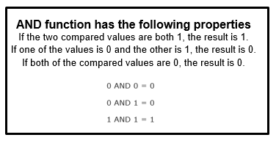

**Steps**

1. Host takes its own IP address and ANDs it with its own subnet mask, producing a result.
2. Host then takes the destination IP address and ANDs it with its own subnet mask, producing another result.
3. Host compares the two results. In cases where the ANDing results are identical, it means that the hosts reside on the same subnet. In cases where the results are different, it means that the destination host is remote.

**Example**

* Computer A has an IP address of 192.168.62.14 with a subnet mask of 255.255.248.0.
* It wishes to communicate with host 192.168.65.1.
* In order to determine whether this destination is local or remote, it will go through the ANDing process

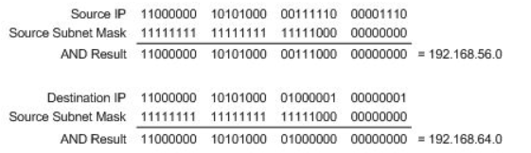

* Computer A is on subnet 192.168.56.0, while the destination host is on subnet 192.168.64.0, which means that Computer A will next be sending the data to a router.

**ANDING Process continued**

**Answer the following**

**Question 1**

* Host A (with IP address 172.16.2.4) wants to communicate with Host B (with IP address 172.16.3.5).
* If the subnet mask for Host A is 255.255.0.0, will the hosts communicate using local transmissions or will they send information to the default gateway?
* Show the workings for the ANDing process below.

|  |
| --- |
| Source IP  Source Subnet Mask  =  AND Result |
| Destination IP  Source Subnet Mask  =  AND Result |

**Question 2**

* Host A (with IP address 192.168.0.10) wants to communicate with Host B (with IP address 192.168.20.2).
* If the subnet mask for Host A is 255.255.255.0, will the hosts communicate using local transmissions or will they send information to the default gateway?
* Show the workings for the ANDing process below.

|  |
| --- |
| Source IP  Source Subnet Mask  =  AND Result |
| Destination IP  Source Subnet Mask  =  AND Result |